Multiple-choice section – choose the correct answer

Questions 1 to 3 refer to the following diagram.

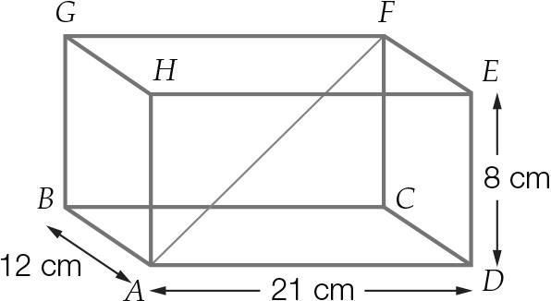

Question 1 [7.1]

The length from A to C is closest to:

A 14 cm B 24 cm C 22 cm D 19 cm

Question 2 [7.1]

Using your answer from Question 1, the length from A to F is closest to:

A 27 cm B 32 cm C 20 cm D 25 cm

Question 3 [7.1]

The angle between CA and FA is closest to:

A 55° B 16° C 68° D 74°

Question 4 [7.2]

Which of the following is equivalent to cos(216°)?

A -cos(54°) B cos(54°) C cos(36°) D -cos(36°)

Question 5 [7.2]

The amplitude and period of the graph, respectively, is:

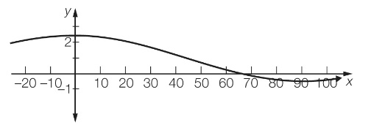

A 3, 180° B 3, 90° C 1.5, 180° D 1.5, 90°

Question 6 [7.3]

To the nearest degree, the solution to , for 90° ≤ x ≤ 360° is:

A 37° B 323° C 217° D 143°

Question 7 [7.4]

A triangular shade cloth is erected over a sandpit at a kindergarten between posts as shown below. The distance between the posts along the side marked *x* is:

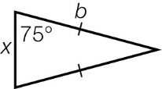

A  B bsin(30°) × sin(75°) C bsin(150°) D 

Question 8 [7.4]

The length of side *x* is:

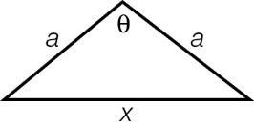

A  B  C  D cos(θ)

Question 9 [7.6]

The sum of the two equal angles of an isosceles triangle is 150° and the two equal sides are each of length  cm. The area of the triangle in cm2 is:

A 0.5x B 2x C 2.5x D 4x

Question 10 [7.6]

Two adjacent sides in a triangle have lengths of a and ka, where k and a are whole numbers. The included angle between the two sides is 30°. Which of the following values for k will produce a square number for the area of the triangle?

A 3 B 5 C 2 D 4

Multiple-choice results: ___ / 10

Short answer section

Question 11 4 marks [7.1]

A right pyramid ABCDE stands on a rectangular base of length 48 cm and width 14 cm. The height of the pyramid is 60 cm. Calculate the angle that the sloping edge makes with the base. Give your answer in degrees, minutes and seconds.

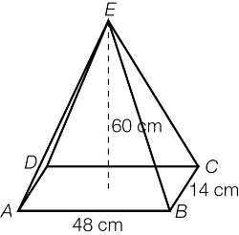

Question 12 2 marks [7.1]

Find the area of the base of the cone in m2.

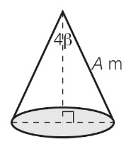

Question 13 2 marks [7.1]

What angle, correct to the nearest second, does the diagonal make with the base of the prism?

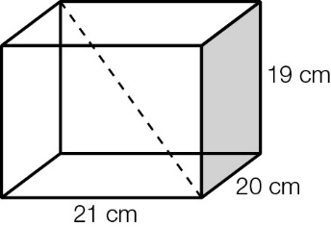

Question 14 6 marks [7.2]

For each of the following, find the equivalent trigonometric ratio using an angle in quadrant 1.

(a) -cos(258°)

(b) tan(417°)

(c) sin(-132°)

Question 15 2 marks [7.2]

The trigonometric ratio cos(θ) is equivalent to -cos(φ), where θ is an angle in quadrant 1. What is the relationship between θ and φ?

Question 16 2 marks [7.2]

For the trigonometric relationship in the graph shown, state the following values.

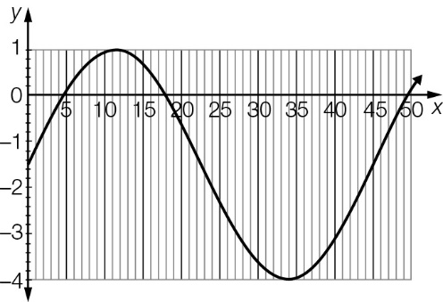

(a) period

(b) amplitude

Question 17 4 marks [7.3]

(a) Find all solutions to the equation  Write your answers correct to 2 decimal places.

(b) In which quadrants are solutions for the equation 3 + 5tan(x) = 0 for 0° ≤ x ≤ 360°?

Question 18 6 marks [7.4]

In ΔABC, ∠ABC = 78°, AC = 10 m and BC = 7 m.

(a) Calculate ∠BAC, correct to the nearest minute.

(b) Find the third angle, correct to the nearest minute.

(c) Find the unknown side length, correct to 1 decimal place.

Question 19 3 marks [7.4]

In ΔABC, ∠ABC = 120°, AB = 3x and BC = x. Show that AC istimes longer than BC.

Question 20 6 marks [7.4]

(a) If a = 2b and c = 7b, show that there is no solution for the angle θ in the cosine formula.  
c2 = a2 + b2 – 2ab cos(θ).

(b) What does it mean if there is no solution to the cosine rule?

(c) If a = 2b, explain why b < c < 3b for a solution to exist.

Question 21 4 marks [7.6]

Calculate the area of the following triangle, correct to 2 decimal places.

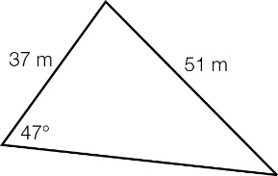

Question 22 2 marks [7.6]

A park is bounded by Tan Street, Sine Avenue and the Great Cosine Highway. The border on Tan Street runs in a north-west direction for 1.6 km between the Great Cosine Highway and Sine Avenue. The border on Sine Avenue runs 2.1 km on a bearing of 189°T. What area does the park cover? Give your answer correct to 2 decimal places.

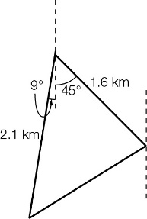

Short answer results: ___ / 43

Extended answer section

Question 23 7 marks [7.6]

A triangular wetland is to be created with one side of length 3y and a second side of length 2y, where y is measured in metres. The angle opposite the longer of these two sides is 149°.

(a) (i) Draw a diagram to represent this area.

(ii) Find the size of the angle included between these sides, correct to the nearest degree.

(iii) Write an expression for the area of the triangle in terms of y.

(b) If the wetland covers an area of 121 m2, find the value of y correct to the nearest metre.

(c) Find the length of fencing required to enclose the wetland.

Question 24 5 marks [7.2, 7.3]

The graph shows the water level (*y* metres) of a river above a marker (*x*-axis) over a period of 12 hours. The first reading was at 7 pm on Sunday.

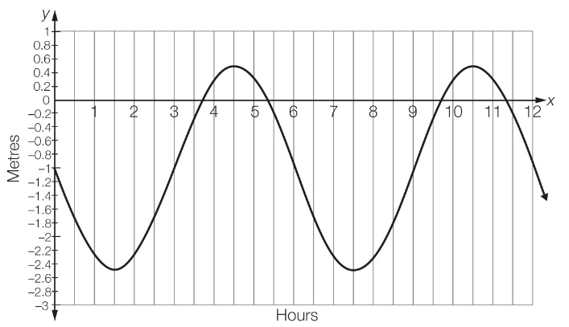

(a) State the period and the amplitude of the graph.

(b) When did the water reach its peak level in the first 12 hours?

(c) The equation of the graph is y = -1.5sin(60*x*) – 1.  
Find the times, in hours, that the water was at the 0 m marker.

(d) Hence, what is the total time the water was above the 0 m marker in this 24 hour period?

Question 25 10 marks [7.5, 7.6]

A side view of a sculpture Petrify has the dimensions shown. Answer the following correct to 2 decimal places.

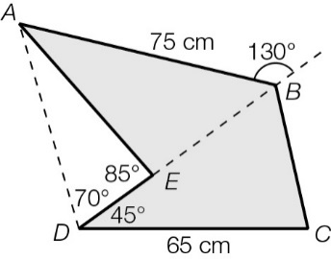

(a) Calculate the area of ∆AEB.

(b) Calculate the length of BD.

(c) Calculate the area of ∆BCD.

(d) Hence, find the cross-sectional area.

(e) Determine the perimeter of the cross-sectional shape.

Extended answer results: ___ / 22

TOTAL test results: ___ / 75